Steps to work with Backend block

Goto VSCode >> File main.tf, variable.tf, output.tf, provider.tf, terraform.tfvars



>> terraform.tfstate file is a creation of terraform apply command holding all resources of aws i.e. infrastructure. Without backend block, terraform stores tfstate file in local.

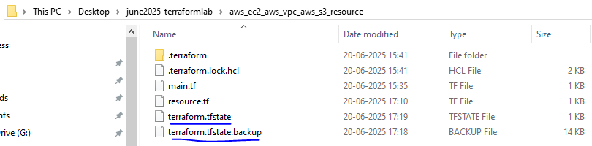

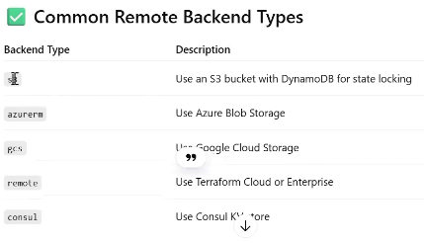

Goto S3 >> Create bucket=”terraform-dev” >> Create bucket



Goto VScode >> Backendblock >> File “backend.tf” >> Add bucket=” terraform-dev“

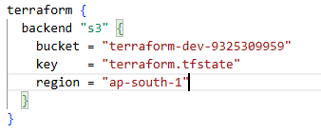

* Terraform init –migrate-state ......to use current configuration as previous
* Terraform plan –var-file dev-terraform.tfvars

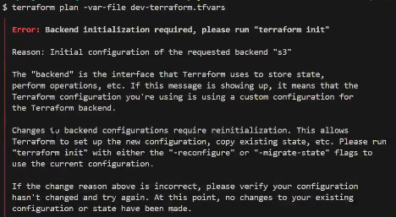

* Terraform apply –var-file dev-terraform.tfvars

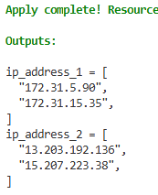 

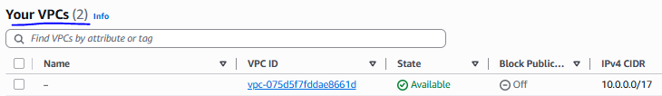

* Terraform destroy –var-file dev-terraform.tfvars

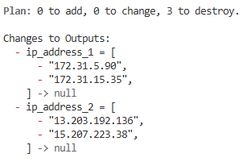

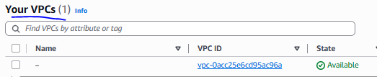

>> Terraform OSS vs cloud vs enterprise